# Validating the CPU in Prototyping Hardware

In this step, we will test the CPU and application, which were generated in the previous steps, on a FPGA prototyping system. For this purpose, we will use the XUPV5-LX110T Prototyping Board from Xilinx shown in Figure 6-1.

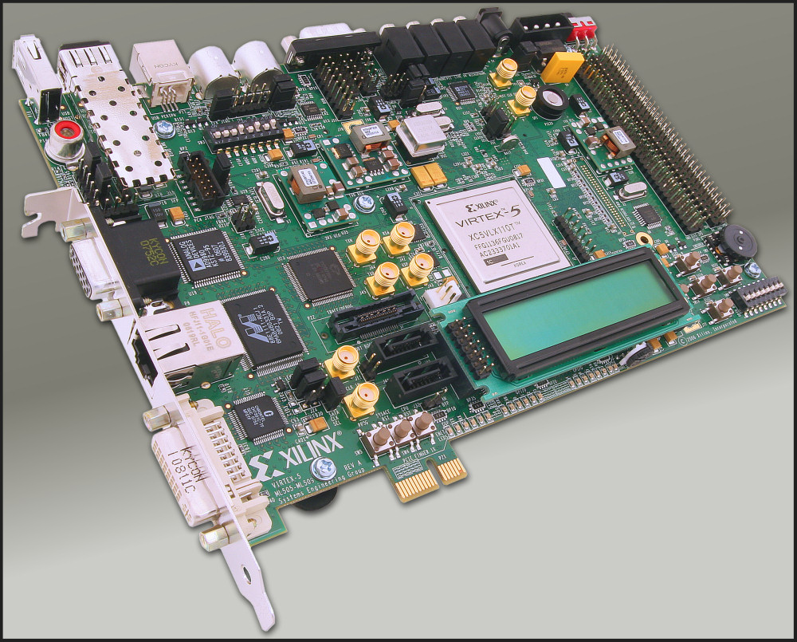

Figure 6‑1: XUPV5-LX110T Prototyping Board from Xilinx [HWAFX]

## Creating the ISE Project

ISE (also called Project Navigator) is a program from Xilinx to support the whole tool-flow from managing your source files during synthesis, map, and place & route until finally uploading the design to the FPGA board.

Start ISE by just executing “ise &” in your ASIP project directory

If you do not already have a project for your current CPU, then create a new one: Select *File* Menu > *New Project*. As “Project Path” you should choose your ASIP Meister Project Directory (e.g. “ASIPMeisterProjects/browstd32/”) and as “Project Name” you can choose something like “ISE_Framework”. This “Project Name” will then automatically be added as new subdirectory to your chosen Project Directory. In the upcoming window “Device Properties”, you have to adjust the values to the data shown in Figure 6-2. Afterwards just press Next > Next > Finish to create an empty project for your CPU. The device settings are needed to make sure, that the map, place and route tools know exactly the type of the target FPGA. For example, you will have a project with following project settings:

Project Name: ISE_Framework

Project Path: home/asip04/ASIPMeisterProjects/browstd32/ISE_Framework

Device Family: Virtex5

Device: xc5vlx110t

Package: ff1136

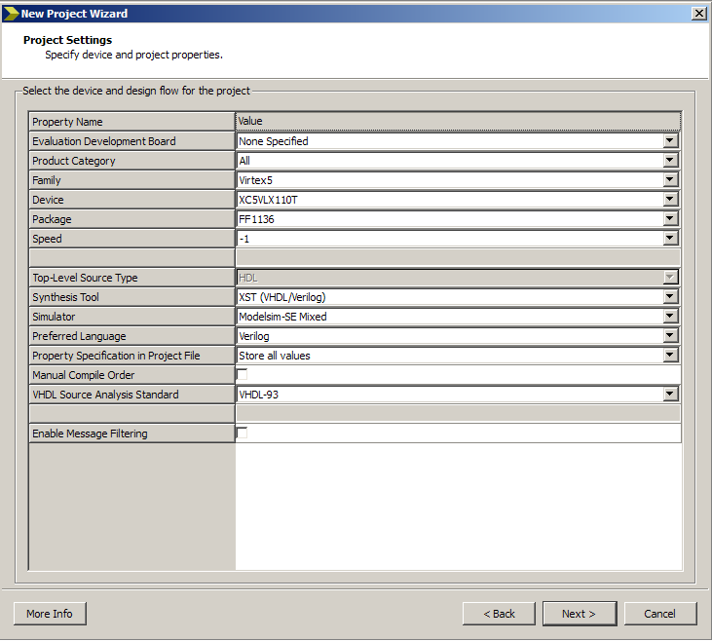

Figure 6‑2: ISE Device Properties

## Adding Source Files to ISE Project

Now you have to add the needed VHDL and constraint files to your ISE project, by right clicking on the XC5VLX110T-1ff1136 entry of your Sources View (at the upper left inside your ISE Window, see Figure 6-3 & Figure 6-4) and choosing “Add Copy of Source”. After ISE has analyzed the type of the files, press OK. Adding a copy of the source has the advantage, that you can locally modify the files and that the CPU files in your ISE project are not overwritten, when you modify your ASIP Meister Project for testing purpose.

There are three types of files that are needed for a hardware implementation:

* CPU VHDL Files
* Framework Files
* Framework IP cores

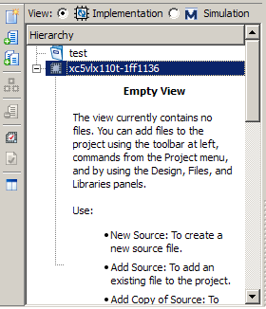

Figure 6‑3: Add Sources

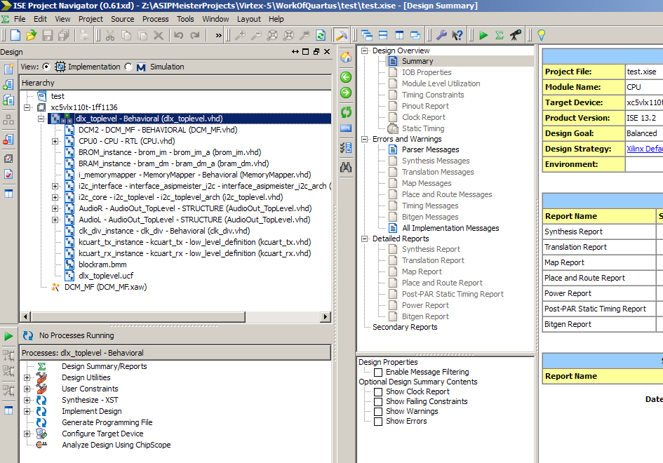

Figure 6‑4: ISE Project Overview

**CPU VHDL Files** have been generated using ASIP Meister and they can be found in the meister/{CPU-Name}.syn directory, as explained in Chapter 2.2.2.

**Framework Files** are important for the connection between CPU, Memory, UART, and all other components. They are predesigned for this laboratory and they are available in /homeasip00/­ASIPMeisterProjects/­TEMPLATE_PROJECT/­ISE_Framework. The framework consists of the following three types of file and all of them have to be added to the ISE project.

* The VHDL files describe how all components are connected together.
* The UCF file describes the user constraints (e.g., which I/O pins should be used for a signal, which clock frequency is requested etc.).
* The BMM file contains a description of the memory buildup for instruction- and data-memory for the CPU. Out of this file …_bd.bmm file will be generated while implementation and this file is then used to initialize the created bitstream with the application data, as explained in Chapter 6.4.

**IP cores** are used within the framework, e.g. memory blocks for instruction- and data-memory or FIFOs for the connection to the LCD. These IP cores are not available as VHDL source code, but instead they are available as pre-synthesized net lists. These files just have to be copied into the directory of your ISE project (no need to actually add them to the project) and then they will be used during the implementation step. The needed files (*.edn, *.ngc) are available in /home/asip00/­ASIPMeisterProjects/­TEMPLATE_PROJECT/­ISE_Framework/­IP_­Cores. Note: The files inside the IP_Cores directory have to be copied to your ISE Project Directory. It is not sufficient to copy the full IP_Cores directory!

After you have added/copied all needed files to your ISE project/directory, your main window should look similar to the screenshot shown in Figure 6-4. In the sources sub window you can see all the source files and how they are structured, i.e. according to the file instantiated by other file.

## Synthesizing and Implementing the ISE Project

In the Processes sub window in the lower left corner of Figure 6-4, the possible actions for each kind of file is shown. To synthesize and to implement your project you have to choose your VHDL-Toplevel in the Sources sub window (“dlx_Toplevel” in the figure) and afterwards you have to double click “Generate Programming File” in the Processes sub window. This will finally create the .bit file that can then be initialized with your CPU instruction- and data-memory and afterwards be uploaded to the FPGA prototyping board.

The whole process of synthesizing and implementing the design is subdivided into several steps that can be seen, if you click on the plus sign in the processes sub window. After the completion of each step, an update of the FPGA Design Summary will be shown in the corresponding sub window in the upper right corner. For example, the device utilization (i.e. the size of your CPU plus the framework) will be shown for the different types of elementary hardware available on the FPGA (e.g. clocks, logic, BRAMs). This is a first hint, how big your CPU actually is, but as it will be explained in Chapter 6.5, these values are not completely accurate, as they not only include the CPU, but also include the Framework, which consists of many different components.

While synthesizing and implementing the design, many warnings will be printed. These warnings (unless created by a user modification, e.g. in the CPU) can be ignored. However, it should be mentioned, that it is very helpful to understand the meaning of these warnings when you are looking for a reason why something is working unexpected in hardware. The challenge here is, that the CPU and the IP cores create plenty of warnings, thus it is hard to locate the serious warnings.

## Initializing FPGA Internal Memory with your Application

After you have finished the synthesizing and implementation step, you receive a bitstream of your ISE project that includes your CPU connected to an internal memory inside the FPGA. Now you have to initialize this FPGA internal memory (called Block RAM or BRAM) with your application instruction- and data memory to execute your program on your CPU. This initialization can be done inside the bitstream itself, i.e. before uploading the bitstream to the FPGA board.

To initialize the bitstream with your application, you need your application as TestData.IM and TestData.DM files, created with “make sim” or “make dlxsim” as explained in Chapter 2.3. However, compared to simulation with dlxsim or ModelSim you have to consider, that you have a limited amount of memory on the FPGA and therefore you have to adjust the position were the stack starts. For the usual simulation, the stack can start at some address e.g, 0xFFFFC and is growing downwards. For hardware execution, this address is too big. For the current hardware prototype, you should use 0xEFFC. You can adjust the place where the stack will start in the file /home/asip00/epp/mkimg/Makefile by adjusting STACK_START_FPGA variable. This Makefile is accessed from your local application Makefile located in the directory of your application (like /home/asip00/­ASIPMeisterProjects/­TEMPLATE_PROJECT/­Applications/­TestPrint/Makefile) and it is evaluated every time you execute this local Makefile. Here you can configure the address of the stack start. To work in hardware this value depends of the size of the available memory in hardware. For our current prototype, “0xEFFC” is the correct value. In case of FPGA, this parameters is set to STACK_START_FPGA.

After the TestData-files for your application are created (see above and Chapter 2.3) and the bitstream of your ISE project is created (see Chapter 6.1 and Chapter 6.3) you can initialize the bitstream with your application data by executing “make fpga” in your application subdirectory. This script will create two new files in BUILD_SIM subdirectory of your application like DirectoryName.mem and DirectoryName.bit. The .mem file contains a memory dump for data and instruction memory and is only a temporary file. The bit file is the final bitstream of your specific CPU surrounded by the framework, and with your application initialized to the BRAM. You have to configure the ISE project that you want to use in the “env_settings” as “ISE_NAME”. The bitstream in this directory will be used to create the application-initialized bitstream.

### Uploading the Bitstream to FPGA Board

After you have created the final bitstream with the initialized BRAM, you can upload this bitstream to the FPGA Board. At first, you have to turn the FPGA Board on.

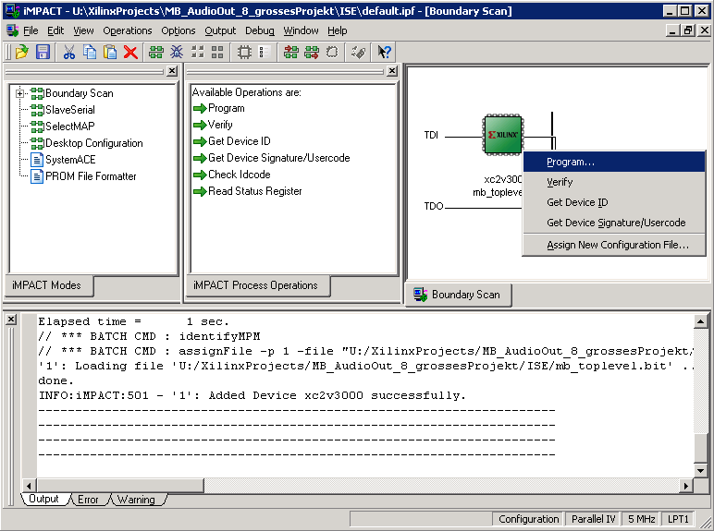

Figure 6‑5: Uploading the Bitstream with iMPACT

After the FPGA Board is running, you have to connect the FPGA to the PC and then initialize it with your Bitstream. Therefore, the software iMPACT from Xilinx, shown in Figure 6-5 is used. If you try to start iMPACT you will receive an error message, complaining about the project-/ and the working directory (because you are not an administrator on this PC). Therefore, right-click the symbol and choose “properties”. Then configure the working directory to “U:” (this is your mounted Linux-server home). Afterwards you can start iMPACT. Create a new project (no need to ‘save’ and ‘load’ a project) and choose the default point “Configure Device using Boundary Scan (JTAG)”. You should see a JTAG chain with one device (the FPGA) as shown in Figure 6-5. Assign the bitstream of your application subdirectory (ASIPMeisterProjects/browstd32/Applications/...) to the Xilinx FPGA device. To reactivate this menu point in a later run without restarting iMPACT, just right-click on the Xilinx device and choose “Assign New Configuration File”. To program the Xilinx device (i.e. the FPGA) choose “Program” as shown in Figure 6-5 and confirm the dialog without any changes with “OK”.

Instead of using graphical iMPACT tool for uploading the bitstream to the FPGA, you can use your Makefile “make upload” in your application subdirectory to upload the combined bitstream to the FPGA. This will automatically scan and program the FPGA.

### Initializing and Using the External SRAM

The size of the BlockRAM (i.e. FPGA-internal RAM; at most 192 Kbyte for our FPGA, but something is used in the Framework for FIFOs etc.) is limited. This is especially problematic if a huge amount of input-data is to be used for an application. Therefore, we have provided external SRAM to the Board, altogether four MB SRAM for IM and four MB SRAM for DM respectively. Our provided ISE Framework (see Chapter 6.1) provides the connection between the CPU and the SRAM. However, before the SRAM can be used it has to be initialized. Currently the SRAM initialization is unexpected slow. Therefore, whatever you want to test on the FPGA board, test a BlockRAM version first. The provided ISE Framework still provides the connection to the BlockRAM additionally. You just have to follow the above tutorials (Chapter 6.4 and 6.4.1) but do not forget to configure STACK_START_FPGA in the Makefile to 0xEFFC. To use the SRAM, follow the following tutorial:

* You have to compile the bootloader.c application (you can find it in /home/asip00/­ASIPMeisterProjects/­TEMPLATE_PROJECT/­Applications/­Bootloader/) with “make sim” and initialize the bitstream with the application using “make fpga”. The resulting bit file contains the bootloader application in the FPGA internal BlockRAM.
* You have to compile the user application (i.e. the one that you actually want to run from the SRAM) with the STACK_START_FPGA configured to 0xFFFFC (in the Makefile; instead of 0xEFFC for BRAM). Note that, besides the normal TestData.IM and TestData.DM additionally the files TestData.IM_uart.txt and TestData.DM_uart.txt are also created in the BUILD_SIM subdirectory.
* You have to start the “dlx_uart.ht” file under windows, which will open the MS Windows HyperTerminal with the correct settings (Bits per Second=230400, Data Bits=8, Parity=None, Stop Bit=1, Flow Control=None). You can find “dlx_uart.ht” in /home/asip00/­ASIPMeisterProjects/­TEMPLATE_PROJECT/­Applications/­Bootloader). However, you may have to adapt the configured COM port, depending on which port you are connected to the FPGA (see Figure 6-6). Under, Ubuntu, you can start HyperTerminal by typing “hterm &” and can configure the settings as mentioned before. After that, you have to click the “connect” button to open the connection. Opening the connection always works without error message, but you have to make sure that the FPGA board is connected to the PC where you are running the HyperTerminal via UART.
* Now configure the FPGA Board to run with 40 MHz (see point (9) in Figure 6-6) and upload the bootloader bit-file (created in first step) with iMPACT. The UART port on the FPGA is configured to work with 40 MHz and if you use a faster or slower frequency, then you will not see the correct output via UART. The bootloader will prompt on the UART-Console for initializing the SRAM. It will ask for three things (you have to answer with pressing ‘y’ or ‘n’): Initialize IM, Initialize DM, and Start Application.
* To initialize IM or DM you have to select ‘y’ and then use the HyperTerminal menu “Übertragung” 🡪 “Textdatei senden” to upload the file TestData.IM_uart or TestData.DM_uart.
* If you do not start the application in the IM-SRAM (pressing ‘n’ when asked) OR when the IM-SRAM application is finished OR when you press the reset button THEN you will come back to the bootloader.



Figure 6‑6: HyperTerminal settings

### Hardware Specific Limitations of the Application

Many kinds of applications can be simulated with dlxsim or ModelSim, but to be able to be executed in hardware, there are some further limitations, which have to be considered. The most obvious point is the limitation of the available memory for instructions and data on the hardware prototype. Currently there are 16 KB for instruction and 16 KB for data memory available. A part of the “make fpga” script will test, whether the your application binary including program and static data memory fits into these memory portions, but for dynamic requested data memory, like the stack which is growing with the number of nested function calls cannot be tested at compile time. If you need more memory, you have to use the SRAM instead (see Chapter 6.4.2).

Another point is that there are more NOP instructions needed for hardware execution than for simulation. Therefore, “Makefile” file has to be adjusted accordingly as explained in Chapter 6.4.

The current connection to the data memory does only support word access to the data memory. Thus, the only supported memory access assembly instructions are “lw” and “sw”. The assembly instructions “lb”, “lbu”, “lh”, “lhu” actually work as well, because they load a full word from the memory and extract the required part of it inside the CPU. However, the instructions “sb” (store byte) and “sh” (store half word) will not work in the current hardware prototype and thus have to be avoided! A part inside the “Makefile” script will test, whether some of these unsupported instructions are used and it will generate a warning that this application will not run in the current hardware prototype (though it works fine in dlxsim and ModelSim). As a workaround for accessing bytes (e.g. for string to be printed on the LCD) some special functions are provided in the StdLib directory (see Chapter 8.3).

int storeByte(char* address, int value);

int storeShort(char* address, int value);

With these functions, you can indirectly access specific bytes and half-words by only using “lw” and “sw” assembly instructions.

## Getting Accurate Area, Delay and Critical Path Reports

The results for area and speed for your synthesis result like created with the tutorial in Chapter 6.1 are not accurate. This is, because the provided framework contains extra additions like a state machine to communicate with the LCD via the I2C bus or the data- and instruction memory and its connection to the CPU. These additions, which are needed for running the CPU on the hardware prototype, have a big impact on the measured size and speed of your CPU. Therefore, if you try to compare two different CPUs with the provided framework, you will mainly compare the framework with itself and it is hard to separate, which change in e.g. the CPU frequency is due to a change in the CPU or a more efficient optimization of the synthesis program due to a better interaction of CPU and framework.

To come around the above-mentioned problems, one might suggest synthesizing the plain CPU without any kind of framework to get accurate data without any impact of other components. Nevertheless, when you look at the output of this synthesis, you will notice, that all internal connections of the CPU will be automatically mapped to I/O-Pins of the FPGA, which has an impact of the size and speed of the synthesis result as well. This impact is due to the fact, that the I/O pins are rather slow compared to the FPGA-internal computation. However, you cannot force the synthesis tools to let the CPU connections unconnected, because then the synthesis tool would notice that there is no input to the CPU and that the output of the CPU is not used at all and thus it would remove the whole CPU for optimization reasons.

The above two examples will give you an impression how difficult it is to measure your results and how difficult it is to interpret the results of your measurements or even more: to compare two different measurements with each other. However, first we have to understand the unit in which the area is measured for FPGAs, i.e. a *Slice*.

The basic block of a fine-grained configurable hardware as in FPGAs is a Look-Up-Table (LUT) as shown in Figure 6-9. The shown example (use four inputs at the top and 1 output at the right side) can realize every Boolean function with four inputs. For each input combination (24=16), a dedicated configuration bit (S0-S15) can be programmed with the corresponding answer. The transistors feed the value of the selected configuration bit to the output. For instance, if S0-S14 are programmed to contain the value ‘0’ and just S15 is programmed to contain the value ‘1’, then this LUT behaves like a 4-input AND-gate.

Many of the 4-LUTs are required, for example, to implement a 32-bit adder and additionally these LUTs have to be connected. FPGAs typically cluster their logic, i.e. they have local blocks with a strong interconnect, but less strong global interconnects. Figure 6-10 shows how Xilinx clusters the LUTs into so-called Slices (including a 1-bit register per LUT) and Configurable Logic Blocks. They have strong interconnects and especial logic for e.g. carry-chains to implement adders. Figure 6-11 shows how the CLBs are connected with configurable switches and dedicated connections.

Altogether, FPGAs provide a huge amount of these logic resources, e.g. the Virtex-II 3000 offers 14,336 Slices. The biggest Virtex-II FPGA (i.e. 8000) offers 46,592 Slices and the biggest Virtex-5 FPGA even offers 51,840 Slices (note: Virtex-5 additionally offers more logic per slice). Additionally they offer dedicated IP cores, e.g. multi-standard I/O ports, Digital Clock Managers, BlockRAMs, multipliers, and even PowerPC cores.



Figure 6‑7: 4-Input 1-Output Look-Up Table (4-LUT) [Kalenteridis04]



Figure 6‑8: CLBs, Slices, and LUTs in a Virtex II FPGA [XUG002]



Figure 6‑9: Array of CLBs and PSMs [XDS060]

### Creating ISE Project for Getting Accurate Reports

To measure the area and delay of your CPU accurately we designed a new framework ISE_Benchmark, which consists of four files: bram_dm.ngc, brom_im.ngc, dlx_toplevel.vhd, and dlx_toplevel.ucf, which can be found in the directory “/home/asip00/­ASIPMeisterProjects/­TEMPLATE_PROJECT/­ISE_­Benchmark/”. The first two files are BlockRAM netlist files for data and instruction memories. The VHDL file is the top level for the whole project. The UCF file is the file, which contains the timing constraints and pins location for the design (in this step, we specify only the clock and reset constraints).

Using this framework, all the CPU connections will be mapped to the FPGA-internal BRAM memory and this will decrease the area needed to implement the project and will give more accuracy to compute the processor area and speed. To obtain the area and speed results for your CPU, your CPU files with this special framework have to be synthesized and implemented as explained in Chapter 6.1 and Chapter 6.3.

### Getting Area Report

In the Process sub window, expand “Place & Route” process. Double clicking on “Place & Route Report” will open new window containing the results needed. Try to find the number of slices in the “Device Utilization Summary” as shown in Figure 6-10.

### Getting Delay Report

In the Process sub window, expand “Place & Route” process and expand “Generate Post-Place & Route Static Timing Report”. Double clicking on “Text-based Post-Place & Route Static Timing Report” will open new window containing the results needed. Try to find minimum Period in the “Design Statistics” as shown in Figure 6-11.

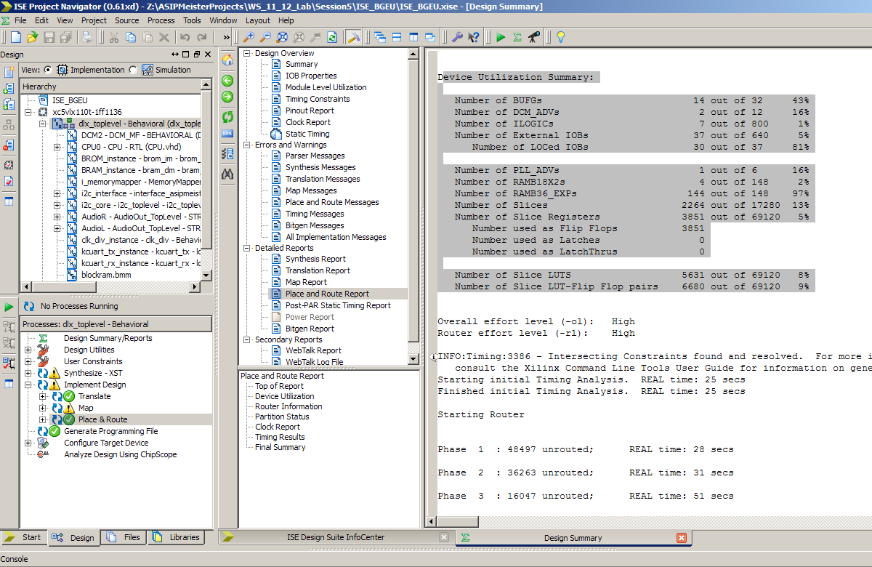

Figure 6‑10: Area Report

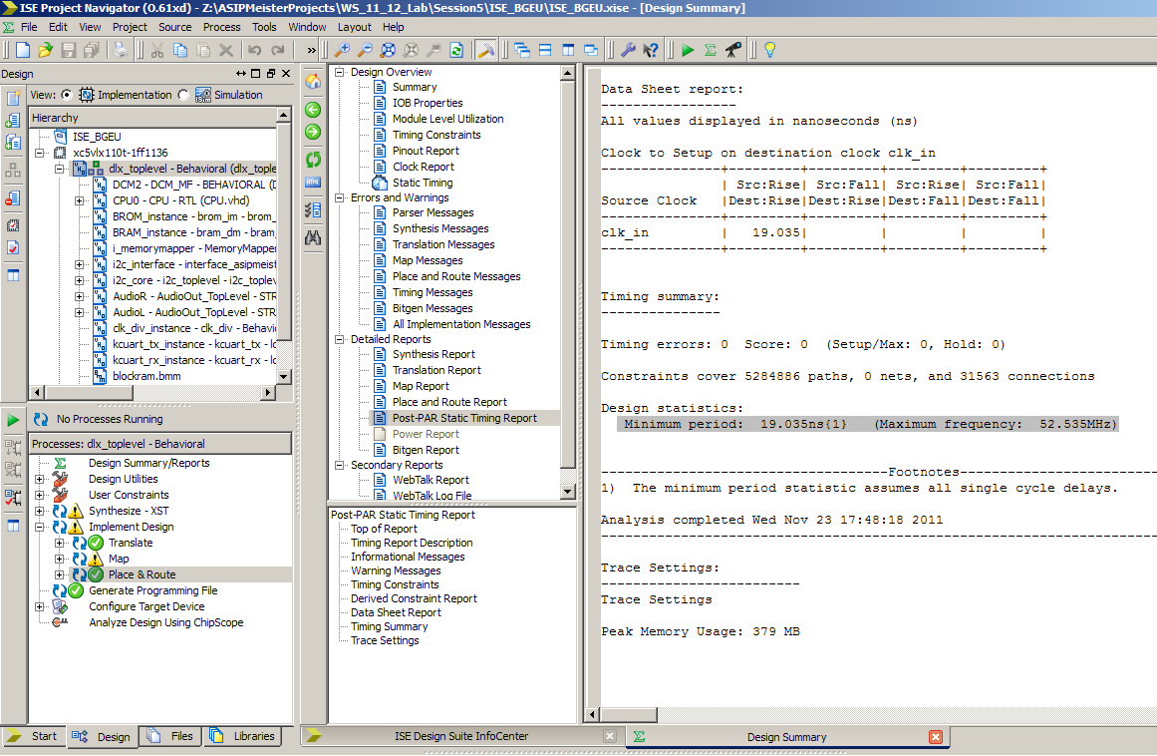

Figure 6‑11: Delay Report

### Getting Critical Path Report

To get the critical path, you have to analyze against the timing constraints. To do that, expand the “Place & Route” process in the sub window Process, and then expand “Generate Post-Place & Route Static Timing Report”. A double click on “Analyze Post-Place& Route Static Timing (Timing Analyzer)” will open a new window for analyzing the timing. In this window, click on “Analyze 🡪 Analyze against timing constraints” as shown in Figure 6-12.

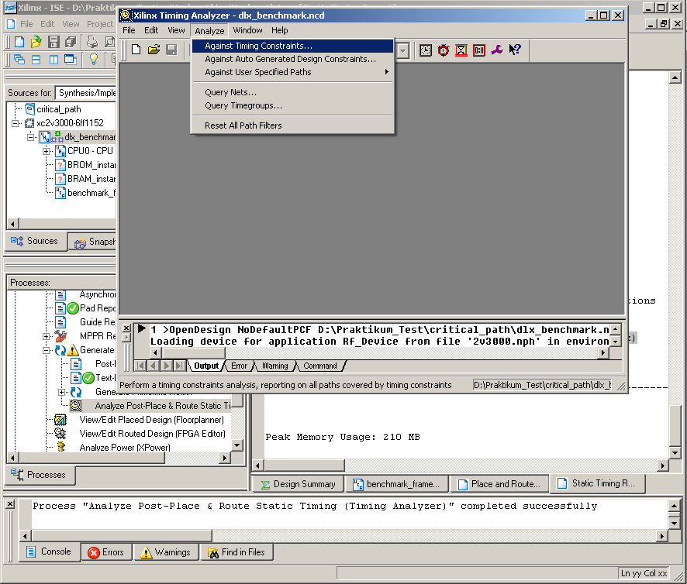

Figure 6‑12: Timing Analyzer Window

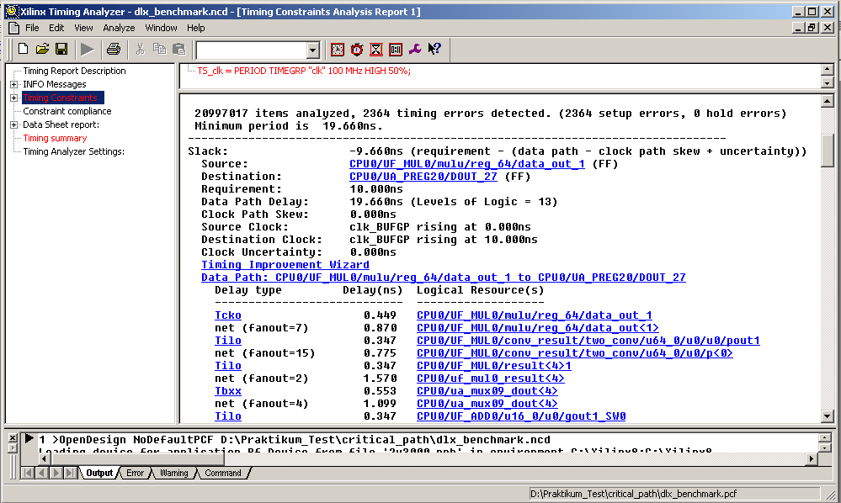

Figure 6‑13: Critical Path in the Xilinx Timing Analyzer

In the “Analyze against timing constraints” window, keep everything as it is and click OK. After a while, the “Timing Analyzer” window will be opened. In this window (shown in Figure 6-13), click on the “Timing constraint” and you will get the critical paths ordered from the longest to the shorter paths. For each path, you will find the total delay and the sub-delays for the signals this path consists of.

In the shown example of Figure 6-13, you can see, that the path has it’s “source” and “destination” inside the CPU0 (i.e. the instantiation of the ASIP Meister CPU, as it is named in the dlx_toplevel.vhd). When looking at the detailed signals this path consists of, you can see, that it starts in the multiplier of the CPU (MUL0, as it is named in the “Resource Declaration” in ASIP Meister), afterwards goes through a multiplexer (mux09) and then goes to the adder (ADD0, as it is named in the “Resource Declaration” in ASIP Meister).

When comparing the maximal frequency of two different CPUs you have to look at the critical paths of both CPUs to understand why maybe the one CPU is slower than the other or vice versa.